Create And Configure IBM Cloud Services-

Create Node-RED Services

|  |  |
| --- | --- |
| Date | 29 October 2022 |
| Team ID | PNT2022TMID23506 |
| Project Name | Project – Smart Farmer-IoT Enabled smart Farming Application |

Download node.js

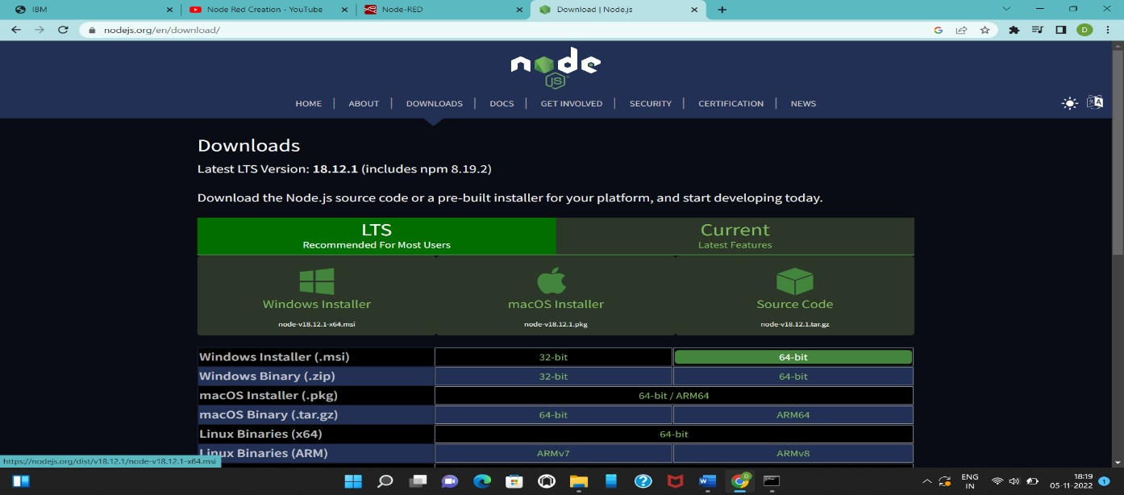

Getting Node-RED link by using command prompt

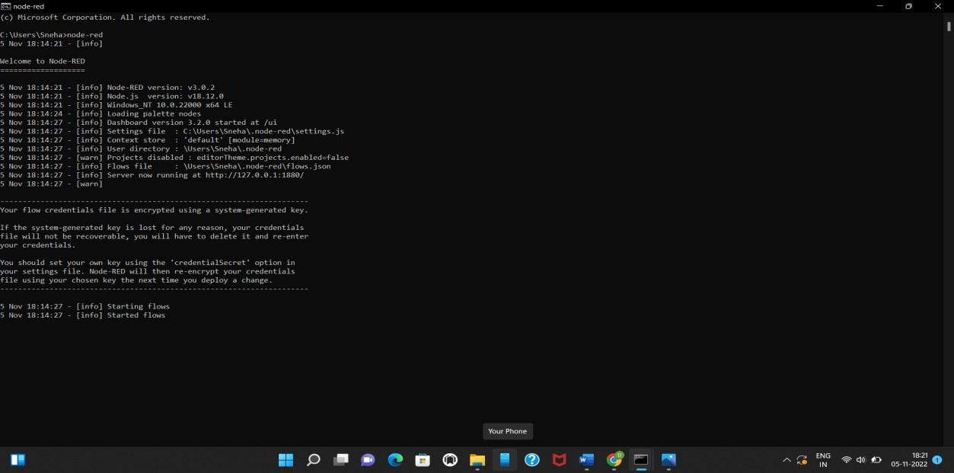

Node-RED

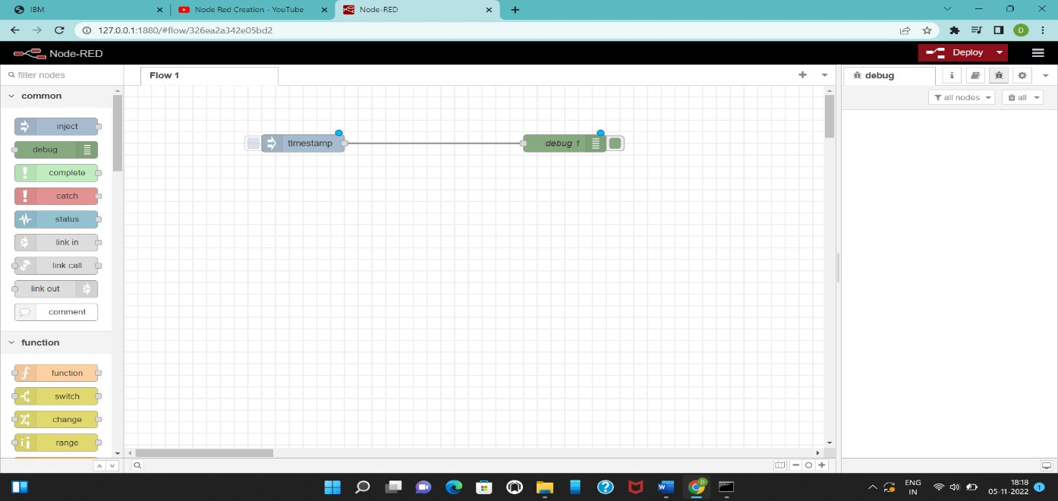

ibmiot to nodered connection

